Information Service

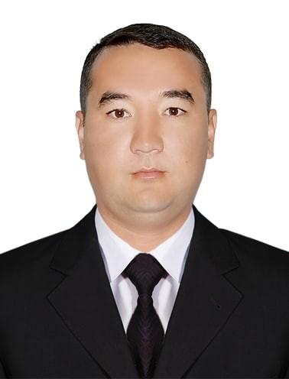
Xojanov Bektursin Muxtarovich
Chief:
Xojanov Bektursin Muxtarovich
E-mail:
pressa.rk@umail.uz
Phone:
0(361) 222-92-72
Address:
203103, Nukus, u. Garesizlik, 50

An employee of the information service of the Council of Ministers of the Republic of Karakalpakstan (press secretary) is in contact with the media. In his activity he publishes decrees, resolutions and orders of the President of the Republic of Uzbekistan, resolutions and orders of the Cabinet of Ministers, resolutions and orders of the Council of Ministers of the Republic of Karakalpakstan and other information in the order established by the Ministry's website and the media

